Application of Light Gradient Boosting Machine (LightGBM) for Expected Goals (xG) Value Prediction in Football Analysis
Fadhil Raihan Akbar¹, Qurrotul Aini ², Nida'ul Hasanati³, Yuni Sugiarti^{4,} Muhamad Nur Gunawan⁵
Abstract— Modern football analysis faces challenges in calculating Expected Goals (xG) metrics accurately and efficiently. Traditional linear models are less capable of reading football data relationships, particularly shot data, while more complex models require very long computational times. The benefit of xG is to assess the probability of a goal occurring from a shot taken by a player; xG is used by coaches, analysts, commentators, and football fans to assess shot quality. This study applies the Light Gradient Boosting Machine (LightGBM) algorithm within the Knowledge Discovery in Databases (KDD) framework to build an xG prediction model using a public dataset from StatsBomb consisting of 73,844 data points. The objective of this research is to evaluate the improvement in accuracy performance and computational efficiency proposed by LightGBM in predicting xG values. The performance results of the LightGBM model show superior improvement when compared to various gradient boosting models from previous studies, with specific metrics: Brier Score 0.0621 and ROC AUC 0.9209. In terms of efficiency, the LightGBM model was able to complete the training process in just 49.75 seconds, far outperforming other comparison models. As a practical implementation, this research also produced an interface for direct visualization and xG prediction. This study makes a significant contribution to modern football analysis by presenting a LightGBM-based model proven to be superior in accuracy and computational efficiency, thus offering a practical solution for better xG modeling.

Index Terms— Football analysis, data mining, expected goals (xG), machine learning, LightGBM.

Introduction
D
n the era of big data, sports analytics has become a vital component in strategic decision-making. Football, traditionally judged by the final score, is now evaluated using advanced metrics, one of which is Expected Goals (xG). xG measures the probability of a shot becoming a goal based on the characteristics of that shot, such as distance, angle, and the body part used [1].
Although xG has become an industry standard, the main challenges lie in prediction accuracy and ease of interpretation. Traditional models like Logistic Regression often fail to capture complex non-linear relationships between game variables. Therefore, modern Machine Learning approaches such as Gradient Boosting have become promising alternative solutions. The Light Gradient Boosting Machine (LightGBM) algorithm was chosen in this study due to its efficiency in handling large datasets and its high accuracy compared to other tree-based algorithms [2].
In addition to model accuracy, the gap between technical analytics and lay users (coaches, pundits, fans) remains an issue. Complex mathematical models are difficult to understand without adequate visualization. This research focuses not only on building an accurate xG model but also on developing a web-based User Interface using the Streamlit framework. The goal is to provide an intuitive decision support tool where users can validate their tactical intuitions through empirical data.
This research aims to fill this gap by applying the Knowledge Discovery in Databases (KDD) approach to develop an accurate xG prediction model using the LightGBM algorithm, and integrating it into a web-based User Interface using the Streamlit framework. The systematic KDD approach was chosen to ensure the data processing from raw to knowledge (model and visualization) is carried out in a structured and valid manner.

Related Work
This section discusses theories and previous research relevant to the development of Expected Goals (xG) models and the algorithms used to provide scientific context for this study.
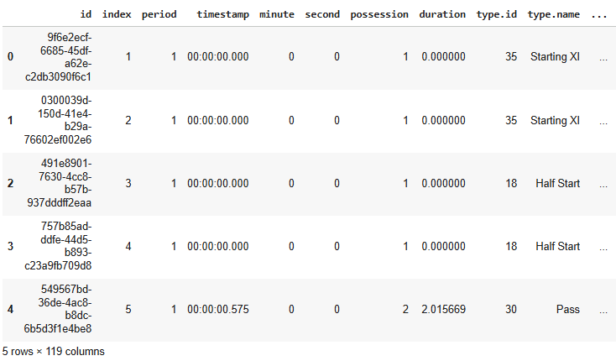
Gambar. 1. Sampel Data Mentah.

Expected Goals (xG)
The xG concept was first popularized by researchers such as Green and Pollard who attempted to measure the efficiency of shots. Rathke's research [1] developed an xG model to evaluate shot efficiency using logistic regression. His findings confirmed that spatial variables, particularly distance and angle of shot, are the most significant predictors in determining the probability of a goal. However, the limitations of linear models in capturing complex interactions have led to the use of more sophisticated methods.

Knowledge Discovery in Databases (KDD)
Knowledge Discovery in Databases (KDD) is a non-trivial process for identifying valid, novel, potentially useful, and ultimately understandable patterns from data. The KDD framework consists of iterative stages: data selection, pre-processing (cleaning), transformation, data mining, and interpretation/evaluation [3]. In the context of sports analytics, KDD provides a standard structure for transforming massive amounts of raw match data into actionable tactical insights, ensuring that the resulting models are not only statistically accurate but also relevant to the domain of knowledge.

Data Mining
Data mining is at the core of the KDD process, which involves applying intelligent algorithms to extract data patterns [4]. In the context of sports, this technique is used to discover hidden relationships between game variables and match results.

Light Gradient Boosting Machine (LightGBM)
LightGBM is a gradient boosting framework that uses tree-based learning algorithms [5]. This algorithm is designed to be distributed and efficient, with the main advantages being faster training speed and higher memory efficiency compared to other boosting algorithms.

Research Method
Table 1.
Data Feature Columns
No | Name | Data Type | Attributes
1 | period | Numerical (ID Category) | Contextual
2 | minute | Numerical (Integer) | Contextual
3 | second | Numerical (Integer) | Contextual
4 | start_x | Numerical (Float) | Spatial
5 | start_y | Numerical (Float) | Spatial
6 | distance_to_goal | Numerical (Float) | Spatial
7 | angle_to_goal | Numerical (Float) | Spatial
8 | position | Numerical (ID Category) | Contextual
9 | shot_outcome (target) | Numerical (ID Category) | Target
10 | shot_body_part | Numerical (ID Category) | Technical
11 | shot_first_time | Boolean | Technical
12 | shot_one_on_one | Boolean | Contextual
13 | shot_open_goal | Boolean | Contextual
14 | shot_aerial_won | Boolean | Contextual
15 | shot_key_pass | Boolean | Contextual
16 | possession | Numerical (Integer) | Contextual
17 | play_pattern | Numerical (ID Category) | Contextual
18 | under_pressure | Boolean | Contextual
19 | shot_technique | Numerical (ID Category) | Technical

This study adopts the Knowledge Discovery in Databases (KDD) framework to ensure a systematic data analysis process. The research stages include Data Selection, Preprocessing, Transformation, Data Mining, and Evaluation.

Data Selection
This study uses secondary data obtained from StatsBomb Open Data [3]. To maintain consistency in game patterns and tactical validity, the data was filtered using the following criteria: (1) Men's soccer competitions, and (2) Professional level (Non-Youth). The final dataset includes thousands of shot event data collected from various top European leagues.
To provide an overview of the data used, here is a sample representation of raw data from the StatsBomb dataset before further processing:

Preprocessing & Transformation
At this stage, raw data is cleaned and reformatted to be suitable for modeling:

Data cleaning
Handling missing values and removing irrelevant or redundant features.

Spatial feature transformation
Field coordinate data (x, y) is processed into new features, Distance to Goal and Shooting Angle. Distance is calculated using the Euclidean formula from the shooting point to the center of the goal. Then the angle is calculated using a trigonometric function (arc tan) to measure the shooter's angle of view relative to the goal [6].

Use of categorical features
Categorical features such as body part, play pattern, and shooting technique are used directly based on their ID (identification number) values without additional encoding, because the LightGBM algorithm can process these numerical inputs effectively.
This study uses a number of extracted features to predict xG values [7]. These features include spatial, technical, and game situation aspects as detailed below [8]:

Data Mining
This stage is the core of the KDD process, where patterns are extracted using Machine Learning algorithms. This study uses the Light Gradient Boosting Machine (LightGBM) algorithm. This process includes:

Data splitting
Division of training data and test data with a ratio of 90:10.
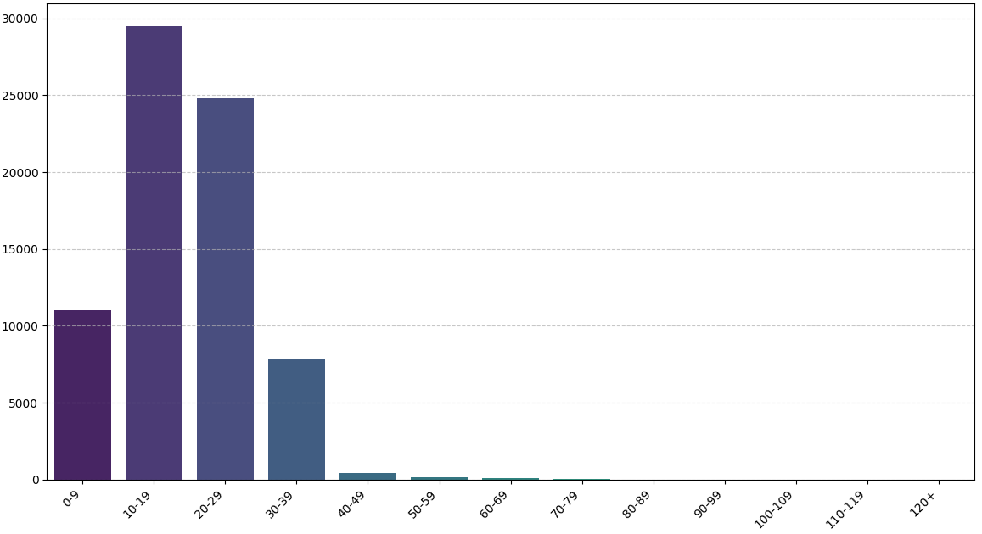
Fig. 3. Distribution of Data Distance to the Goal.

Hyperparameter tuning
Using RandomizedSearchCV to find the optimal parameter combination (learning rate, n_estimators, num_leaves) to prevent overfitting.

Model calibration
Applying isotonic calibration so that the predicted probabilities accurately represent the actual probabilities of events.

Evaluation
Model performance is evaluated to validate the patterns found:

ROC-AUC
Measures the model's ability to discriminate between goals and non-goals.

Brier Score
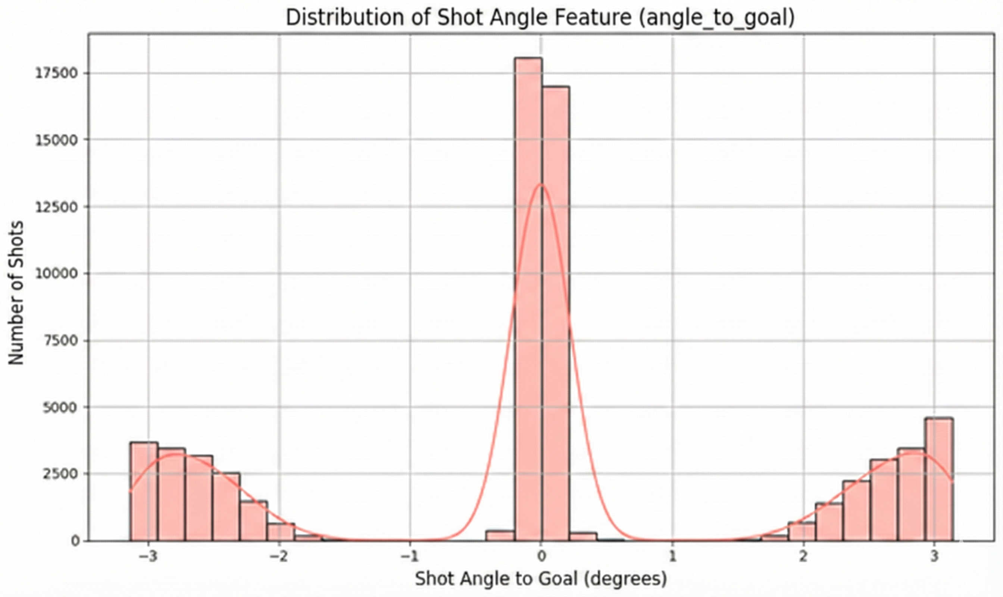
Fig. 4. Distribution of Data Angle to the Goal.
Measures the accuracy of prediction probabilities.

Visualization
Model results are translated into an interactive web interface using Streamlit to facilitate interpretation of tactics by end users.
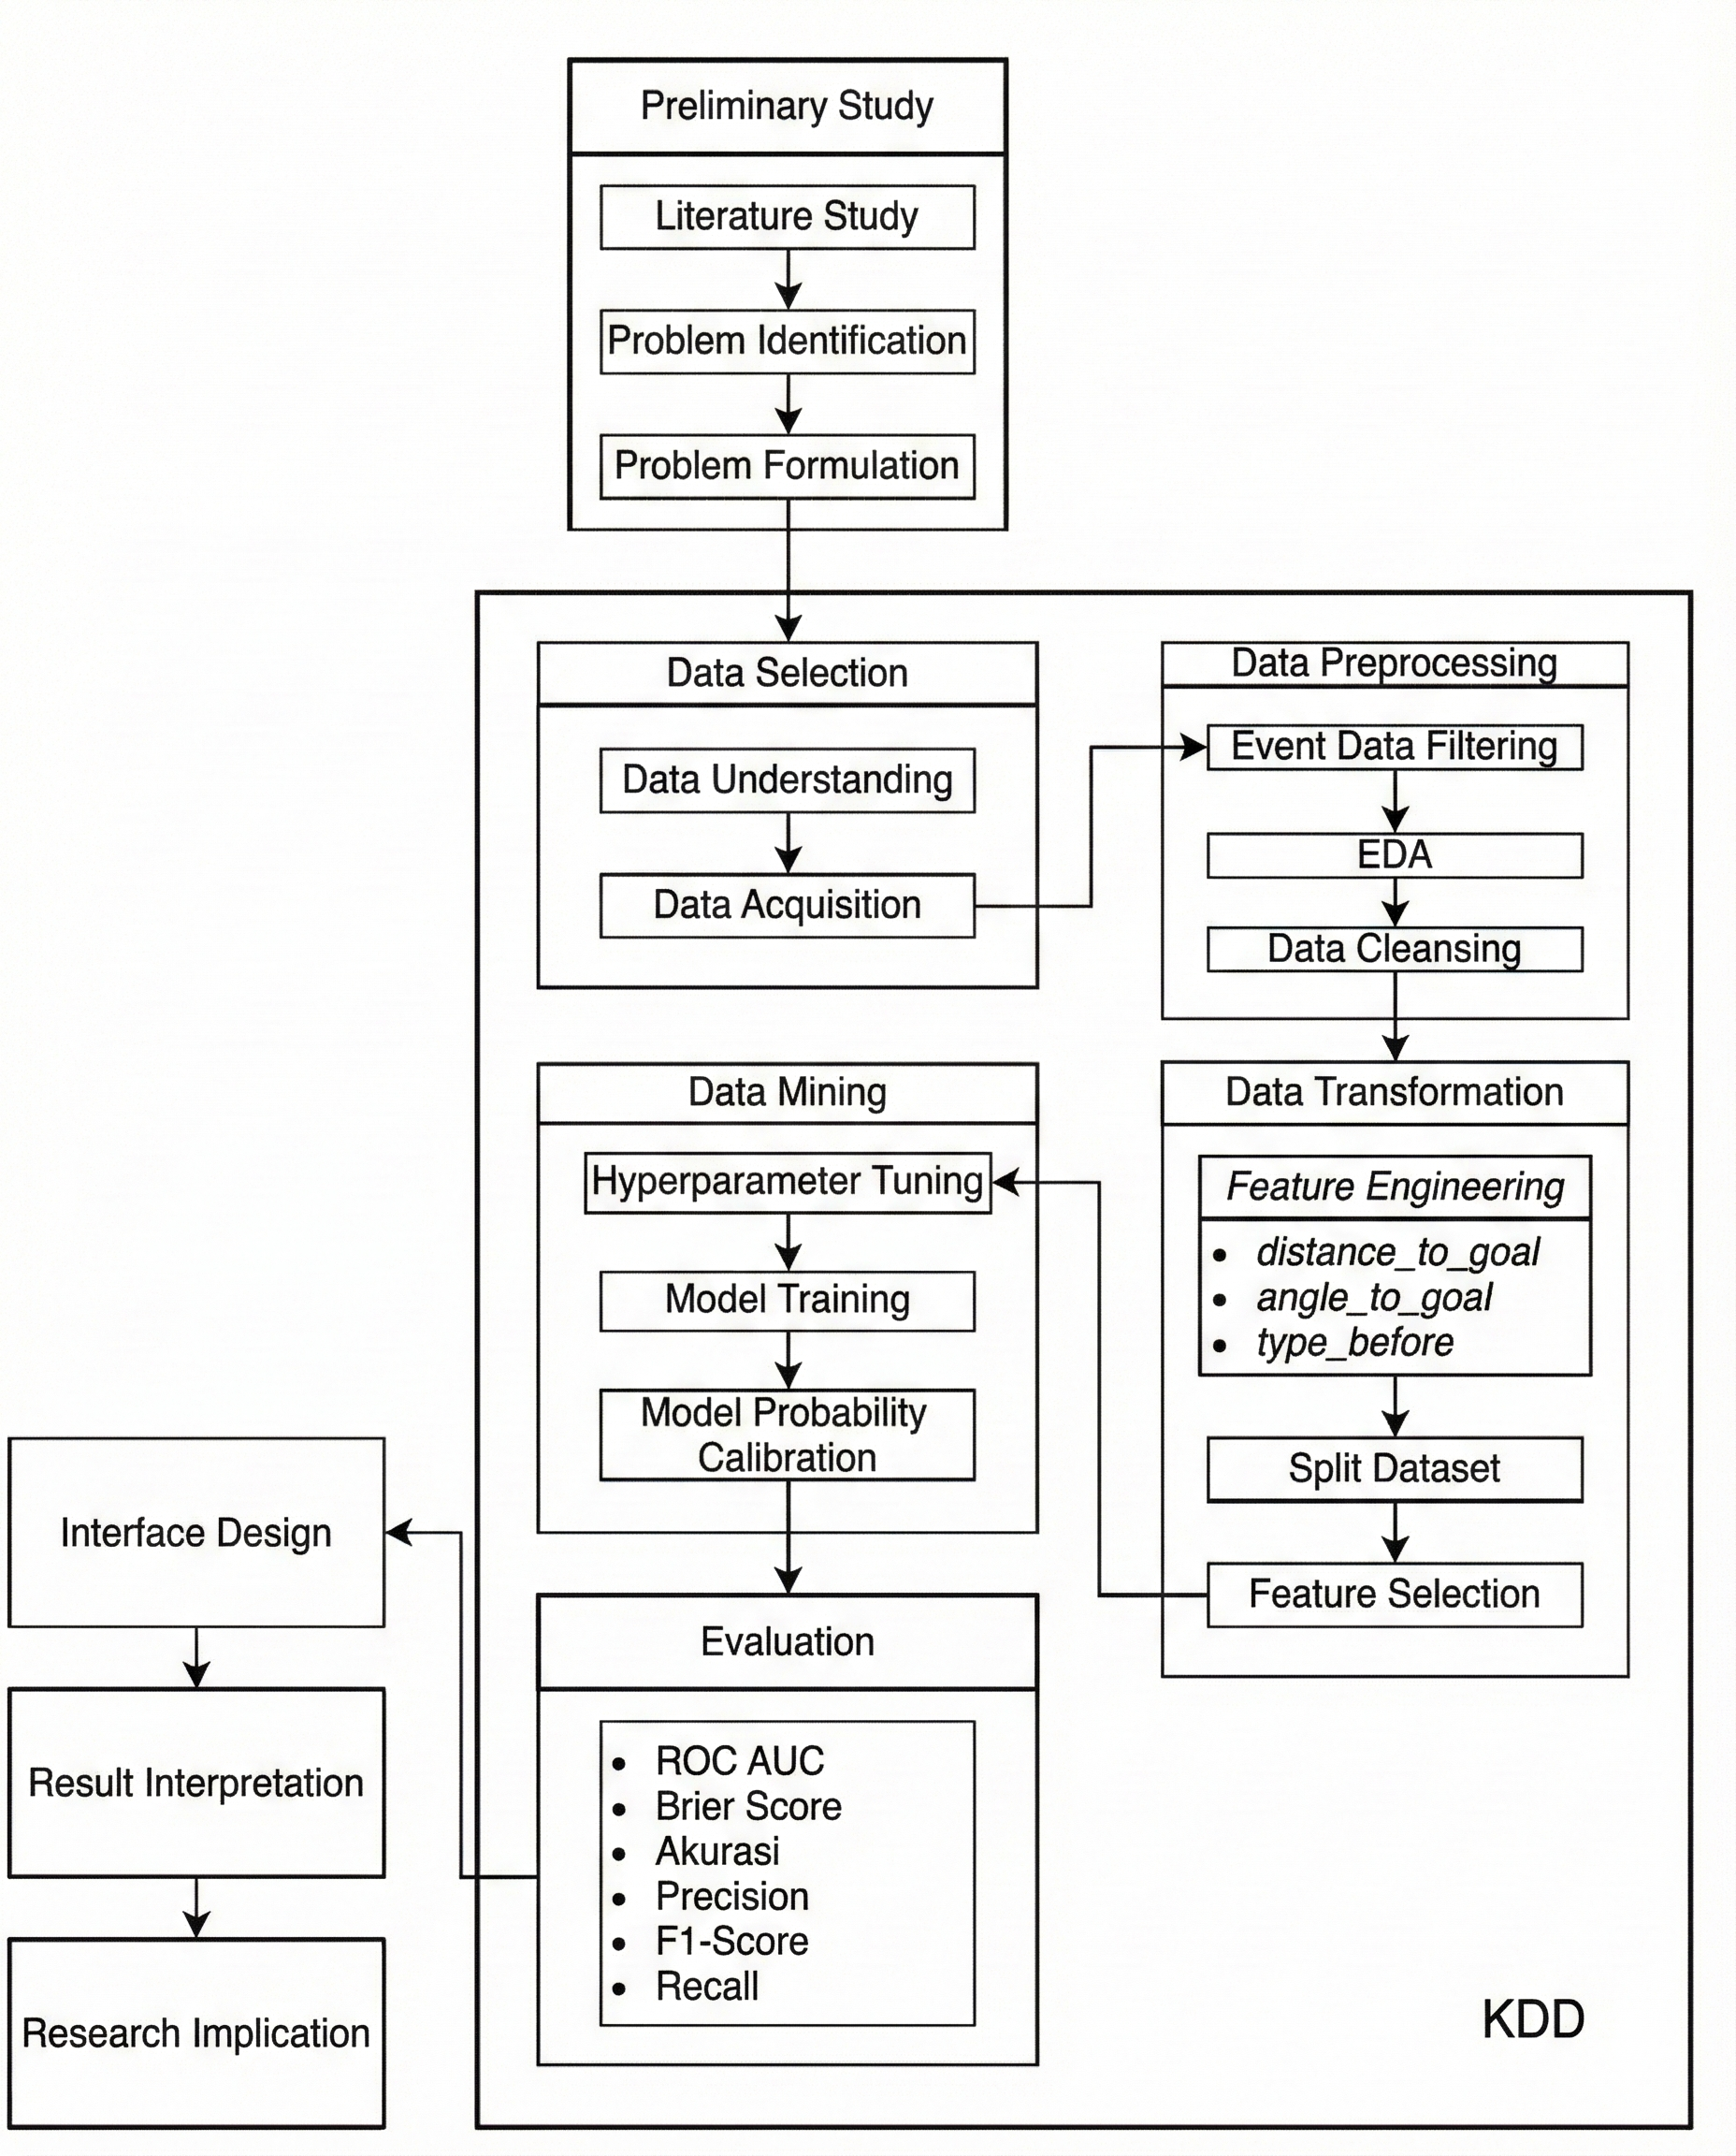
Fig. 2. Research Stages.

Result

Exploration Data Analysis
The results of descriptive statistical analysis provide initial insights into the characteristics of shots in soccer. As shown in Figure 3, the distribution pattern of shot angles can provide information about the quality of opportunities.
In addition to angle, the distribution of shot distance is also a crucial factor in determining xG. This is shown in Figure 4.

Model Performance
Model evaluation was conducted to measure prediction reliability. Figure 5 shows the ROC (Receiver Operating Characteristic) curve of the trained LightGBM model.
Figure 5 The ROC curve shows the classification performance of the model. The area under the curve (AUC) of 0.92 indicates that the model has good discrimination capabilities in distinguishing between potential goals and non-goals.
In addition to classification capabilities, probability accuracy is measured using a calibration curve as shown in Figure 6.
Figure 6 shows a calibration curve comparing the predicted probability (X-axis) with the actual frequency of occurrence (Y-axis). A plot line that is close to a perfect diagonal (dotted line) indicates that the model has been calibrated well (reliable).
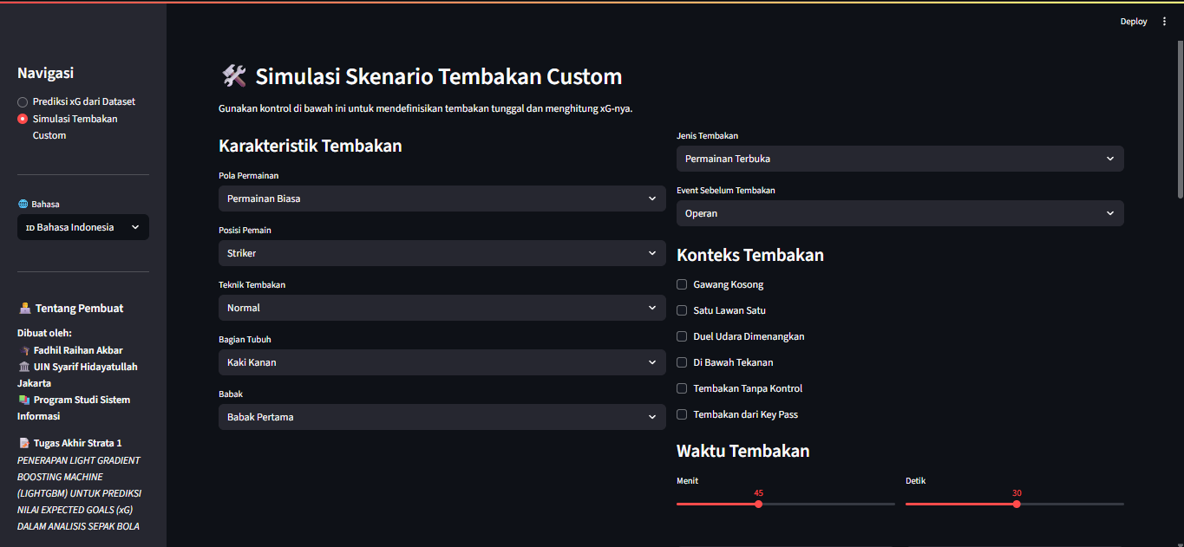
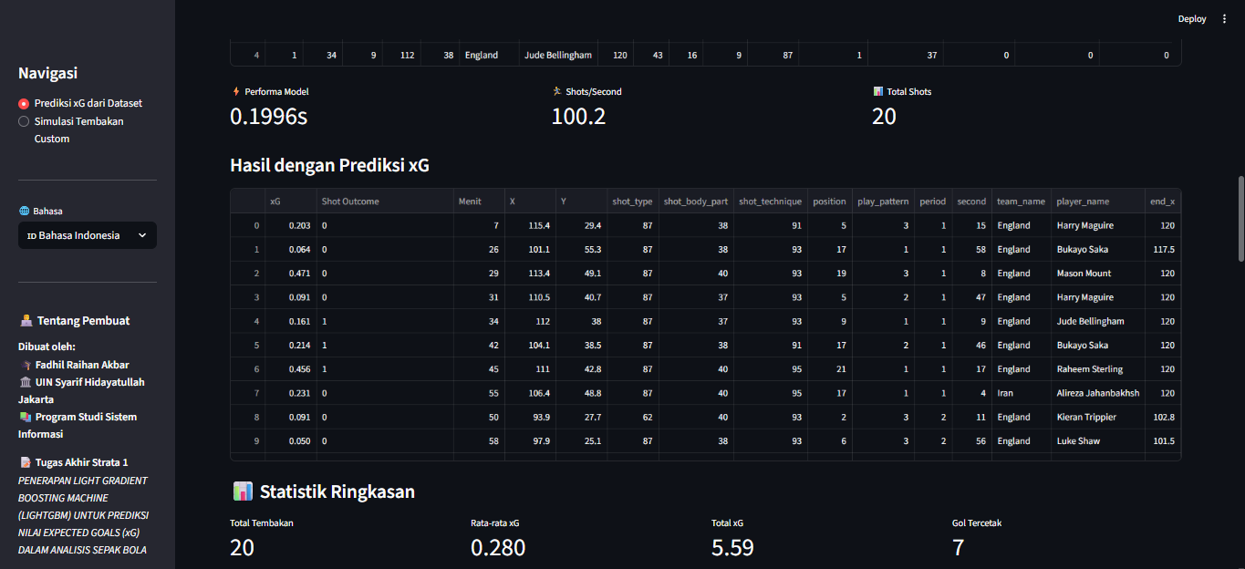
Fig. 6. Streamlit-Based xG Prediction Application Interface Display.
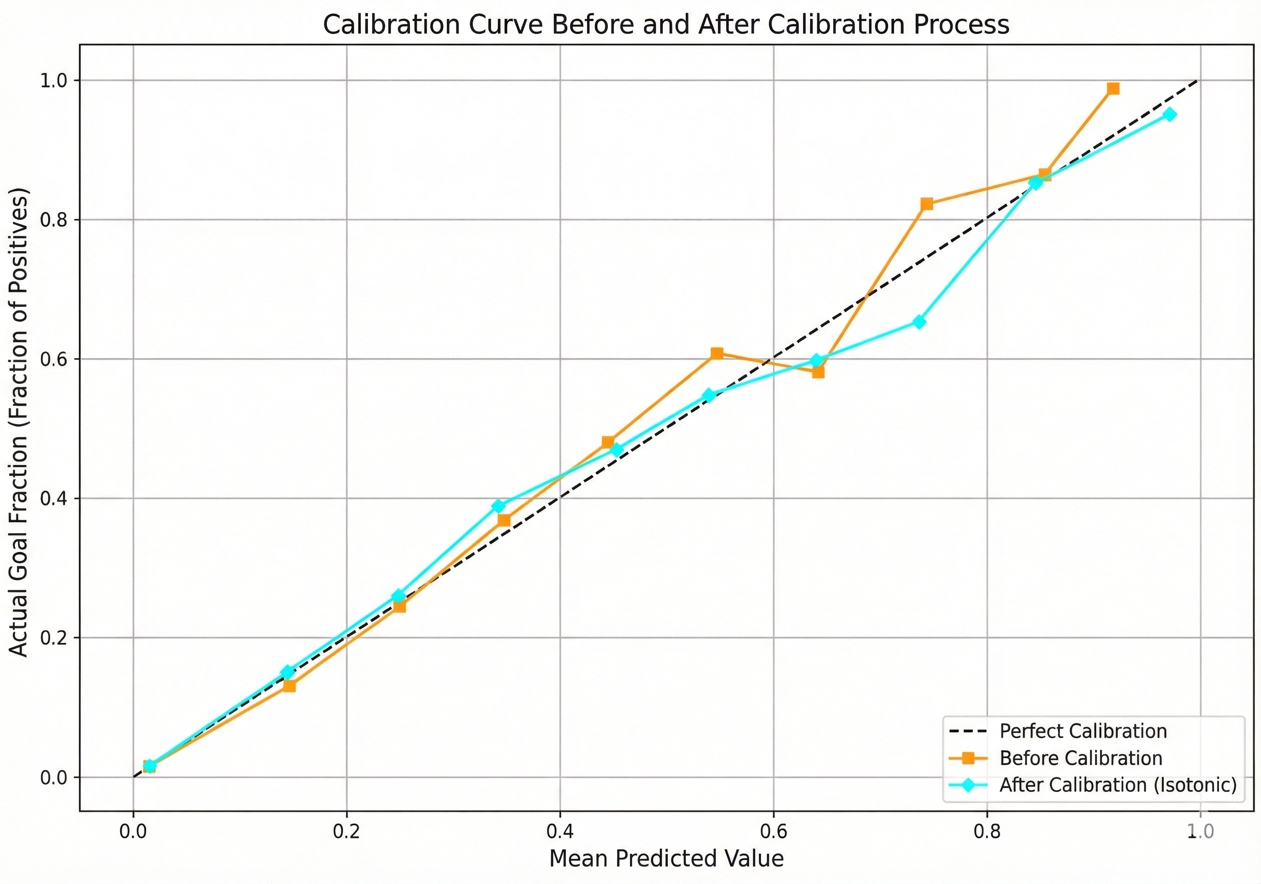
Gambar. 6. Kurva Kalibrasi.
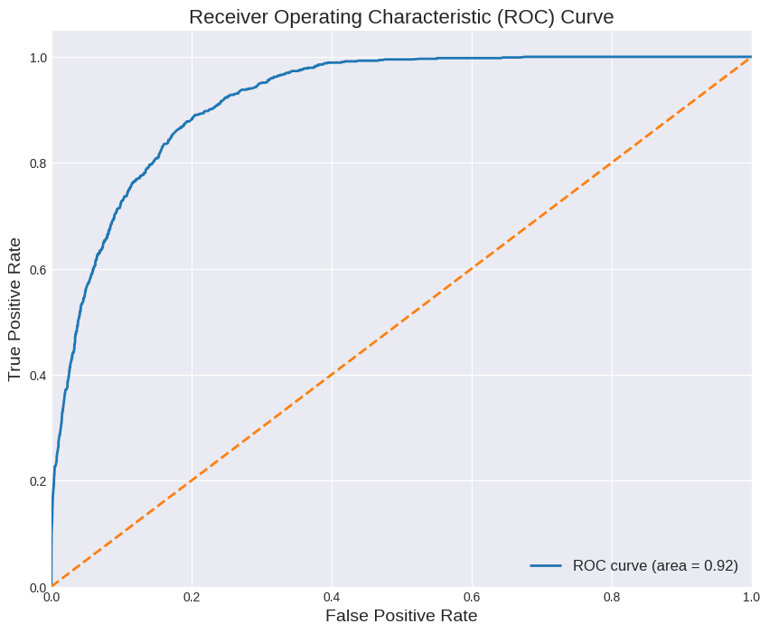
Fig 5. ROC curve.

Table 2 below summarizes the quantitative evaluation metrics of the model:
Table 2.
Model Evaluation Results
Evaluation Metric | Score
ROC-AUC | 0.92
Brier Score | 0.0621
Second (time) | 49.75

User Interface Implementation
The final stage of the KDD framework is interpretation, which is realized through an interactive web application. Figure 6 shows the main display of the developed application.

Conclusion
This study successfully applied the LightGBM algorithm within the Knowledge Discovery in Databases (KDD) framework to predict Expected Goals (xG) values with a high degree of accuracy. The use of spatial and technical features extracted from StatsBomb Open Data proved to be significant in determining goal probabilities. Furthermore, the development of a Streamlit-based interface successfully transformed complex mathematical models into interactive analysis tools that are easily accessible to non-technical users. This research concludes that the integration of advanced Machine Learning with interactive data visualization is key to increasing the adoption of data analytics in soccer. For further development, it is recommended to integrate player tracking features to take into account the positions of defenders and goalkeepers in more precise xG calculations.

Acknowledgments
The author would like to express his deepest gratitude to Mr. Husni Teja Sukmana, S.T., M.Sc, Ph.D. as Dean of the Faculty of Science and Technology, Mrs. Dr. Qurrotul Aini, M.T., as Head of the Information Systems Study Program and Supervisor I, Mr. Ir. Eri Rustamaji, MBA, as Secretary of the Study Program, and Mrs. Nida'ul Hasanati, S.T., MMSI., as Supervisor II, for all the guidance, knowledge, and support provided during the preparation of this research. We would also like to express our gratitude to the entire academic community of UIN Syarif Hidayatullah Jakarta.

References
- M. Rathke, "An examination of expected goals and shot efficiency in soccer," Journal of Human Sport and Exercise, vol. 12, no. 2proc, pp. S514-S529, 2017.
- A. D. Hartanto, Y. Nur Kholik, and Y. Pristyanto, “Stock Price Time Series Data Forecasting Using the Light Gradient Boosting Machine (LightGBM) Model,” JOIV : Int. J. Inform. Visualization, vol. 7, no. 4, 2023.
- A. Solanki and H. Sharma, "A Review on Knowledge Discovery in Databases," International Journal of Computer Applications, 2021.
- J. Han, J. Pei, and H. Tong, Data Mining: Concepts and Techniques, 4th ed. Morgan Kaufmann, 2022.
- G. Ke et al., "LightGBM: A Highly Efficient Gradient Boosting Decision Tree," in Advances in Neural Information Processing Systems, 2017, pp. 3146–3154.
- H. Eggels, R. van Elk, and M. Pechenizkiy, "Explaining soccer match outcomes with goal scoring opportunities predictive analytics," in Proceedings of the 3rd Workshop on Machine Learning and Data Mining for Sports Analytics, 2016.
- G. Anzer and P. Bauer, "A goal scoring probability model for shots based on synchronized positional and event data in football (soccer)," Frontiers in Sports and Active Living, vol. 3, p. 624475, 2021.
- StatsBomb, "StatsBomb Open Data," GitHub Repository, 2022. [Online]. Available: https://github.com/statsbomb/open-data.

______________________________________________________________This paragraph of the first footnote will contain the date on which you submitted your paper for review, revised, and accepted. ¹F. R. Akbar, UIN Syarif Hidayatullah Jakarta Indonesia (e-mail: fadhil.raihanakbar21@mhs.uinjkt.ac.id). ²Q. Aini, UIN Syarif Hidayatullah Jakarta Indonesia (e-mail: qurrotul.aini@uinjkt.ac.id). ³N. Hasanati, UIN Syarif Hidayatullah Jakarta Indonesia (e-mail: nidaul.hasanati@uinjkt.ac.id). ⁴Y. Sugiarti, UIN Syarif Hidayatullah Jakarta Indonesia (e-mail: yuni.sugiarti@uinjkt.ac.id). ⁵M. N. Gunawan, UIN Syarif Hidayatullah Jakarta Indonesia (e-mail: nur.gunawan@uinjkt.ac.id).

